Language – Translator

Description:

The basic idea behind the project is to translate English to one’s native language and the benefit is that it can translate it into any number of languages at a time. The project takes input in English and can translate it into any language as per user’s requirement.

Problem Statement:

This project helps the people who don’t understand English but are familiar with their native language. So, translating the whole English text to the User’s familiar language.

Steps to translate:

1. Input the given text line by line or in any format.
2. Select the Language Number (one or more than one).
3. Your lines of text are translated!

Project work:

Source Code:

# Language Translation (English - any language)

from googletrans import Translator , LANGUAGES

def translate_lang(text,lang):

## traslation of the given text

try:

for item in lang:

print("Translation in Language Number {}".format(item))

trans=Translator().translate(text, dest = language_dict[item])

print (trans.text)

print("")

except:

print("Language index was not correct{} \n{}".format(lang,text))

def display_languages():

lang_indexes={}

i=0

for Language in LANGUAGES.keys():

lang_indexes[str(i)]=Language

print("{:<3} : {:<10}".format(str(i),LANGUAGES[Language]))

i+=1

print("")

return lang_indexes

def index_lang():

## taking the input for the language no.

lang_index=input("Write language index seperated by space for ex: 10 2 6 5...\n").strip().split(" ")

return lang_index

def inputt():

print("WRITE :q or exit() to finish writing")

text=""

while(True):

z=input()

if(z==":q" or z=="exit()" or z==":Q" or z=="EXIT()"):

break

if(z[-1] in ('.,!?:;')):

text= text+z+'\n'

else:

text = text+z+'.\n'

return text

if __name__=="__main__":

language_dict=display_languages()

sample_text=inputt()

language_no=index_lang()

translate_lang(sample_text,language_no)

Output:

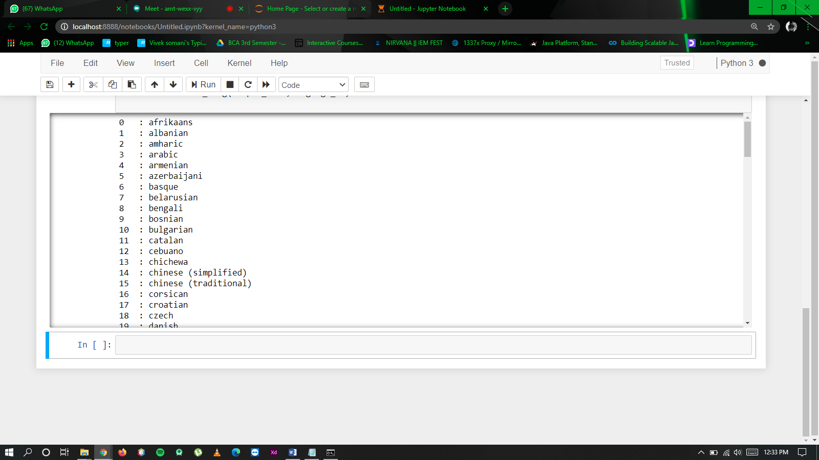

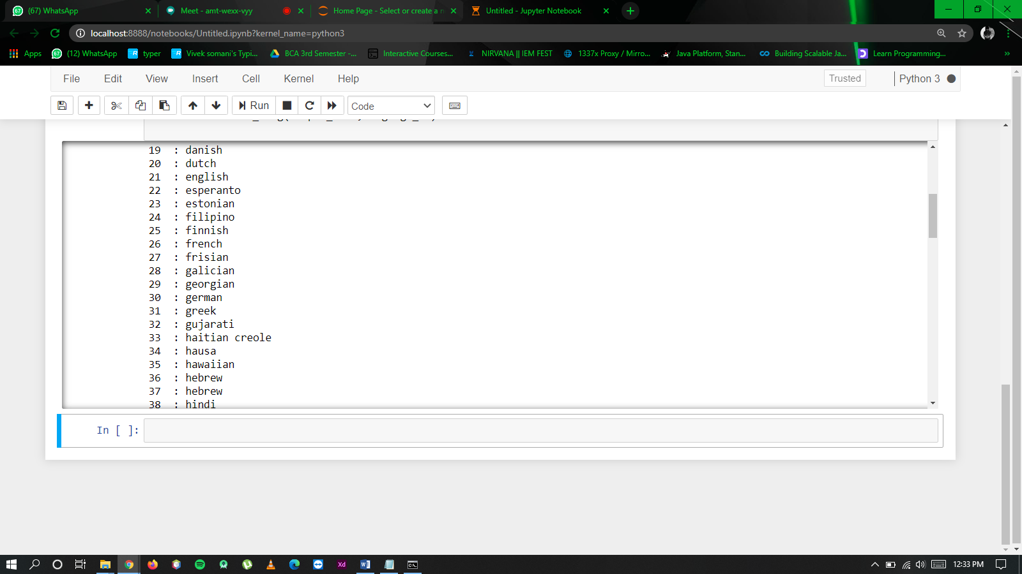

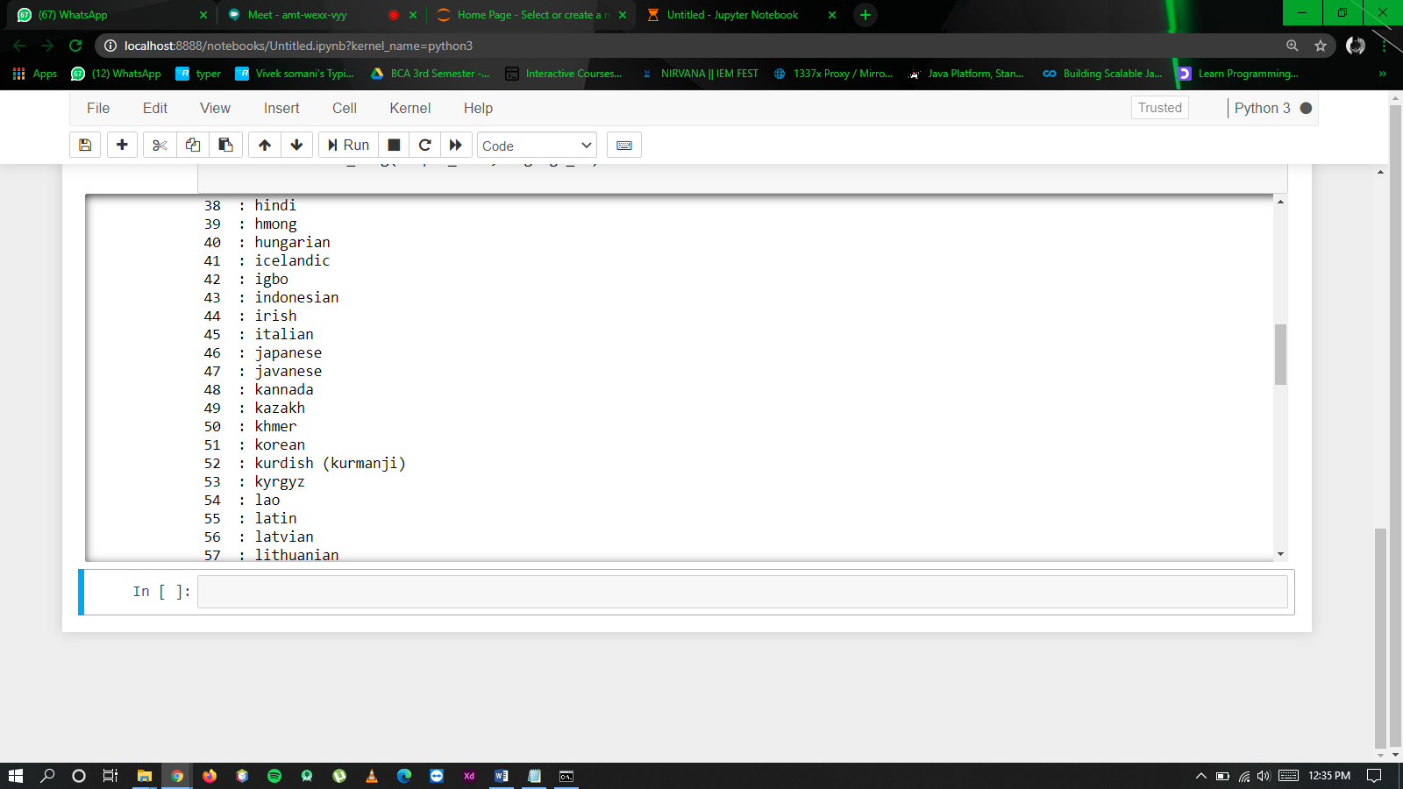

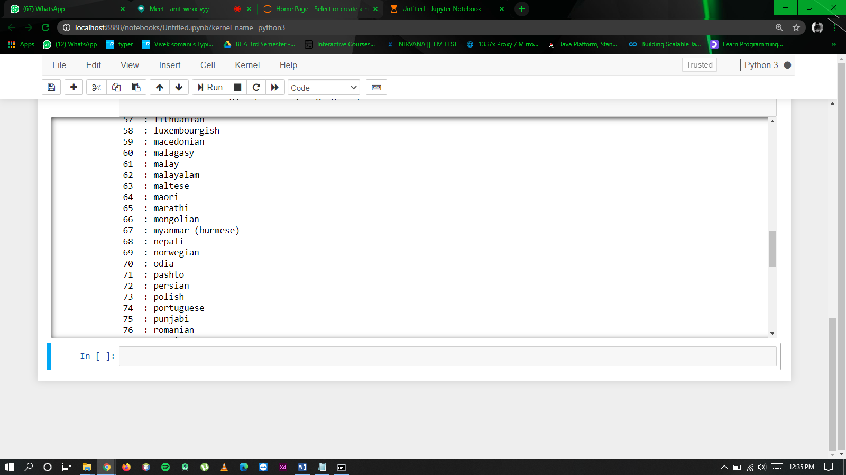

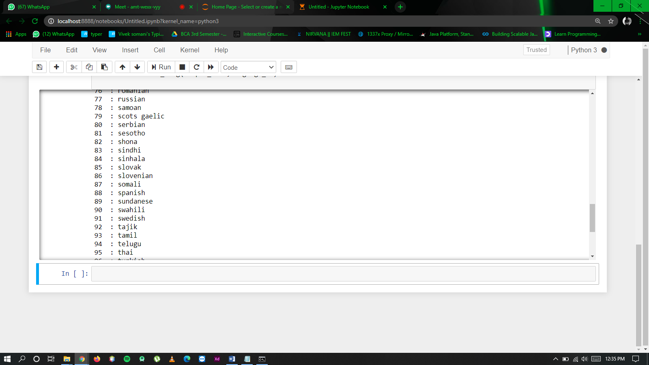

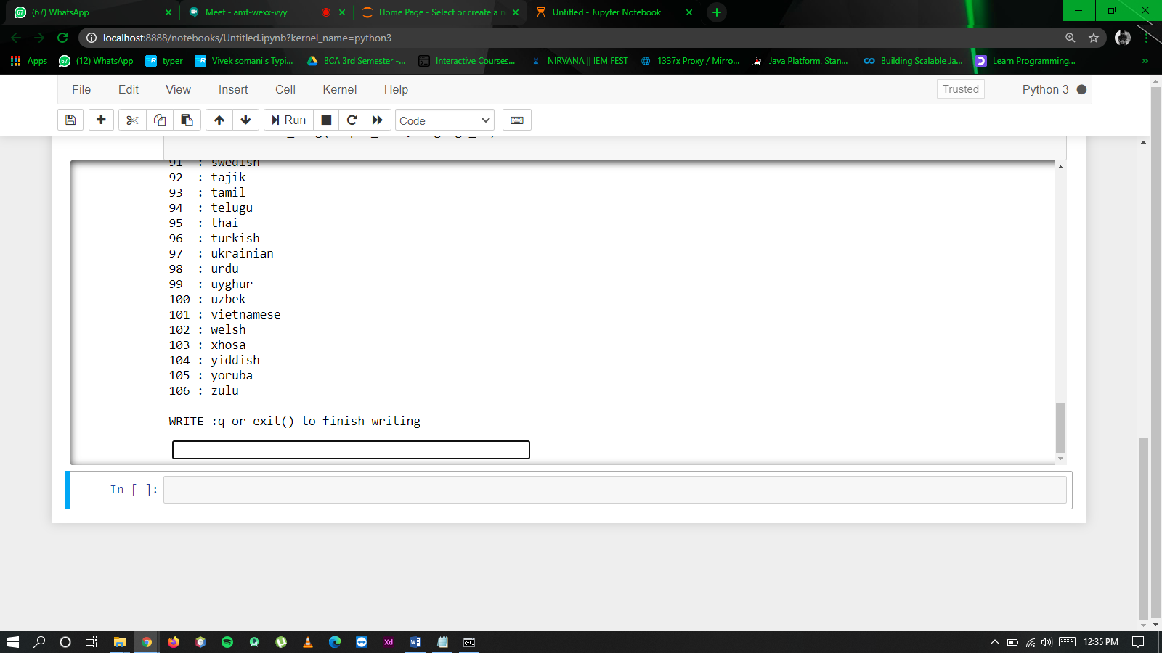

**Now input text….**

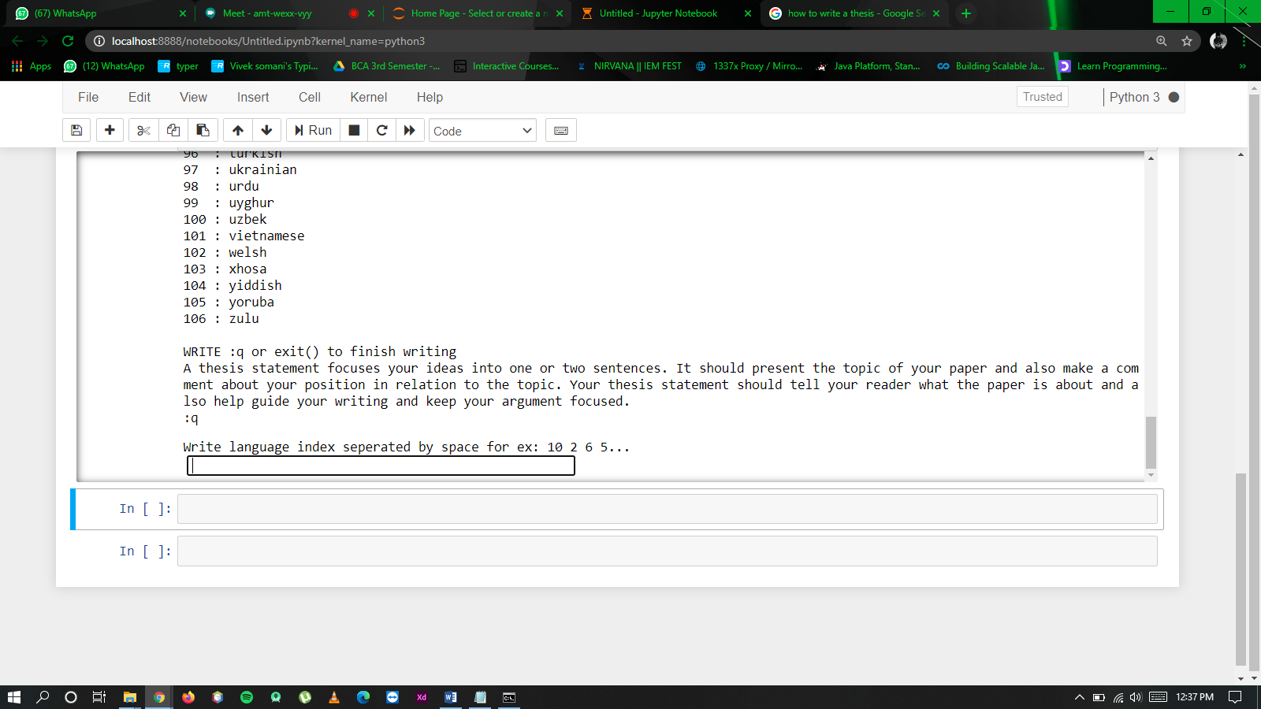

**Now enter the language no….**

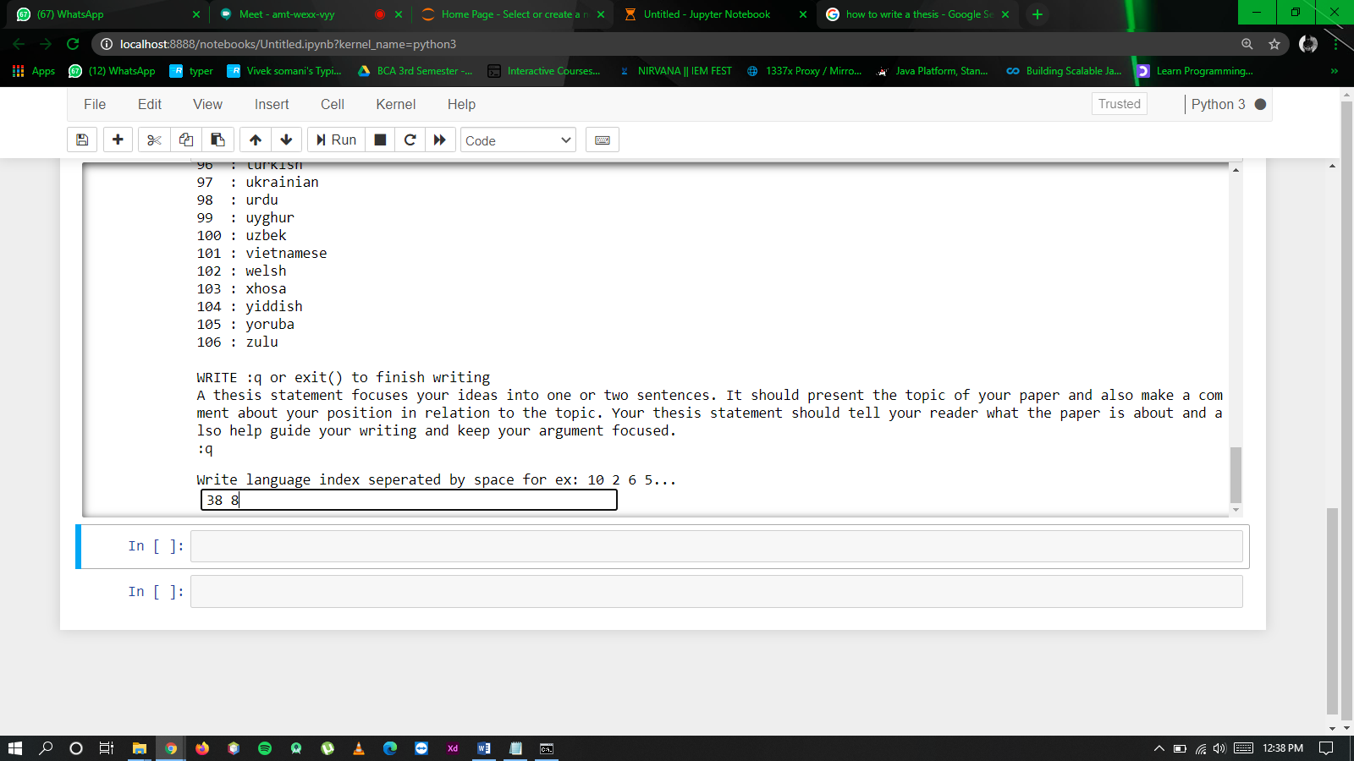

**Final Output:**

